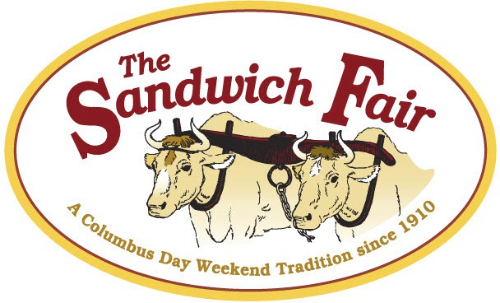

The 2026 Sandwich Fair

ANTIQUE CAR SHOW
Saturday, October 10, 2026
Contact: Dave Patridge
603-707-6843

Please print
Name: Phone: Mailing Address: City, State, Zip Code: E-Mail Address: Miles Driven:

Entry Type
Year: Make & Model: Class:

Entry Fee for each vehicle is $15.00 Entry Fee Enclosed: Check #:

PARADE STARTS AT 1 PM


- Pick up Truck
- Ford Models A & T
- Ford Products
- General Motors Products
- Chrysler Products
CLASSES:
- American Made (other)
- Foreign Made
- Modified or Street Rod
- Special Interest (Please Specify)

Classes 1–8 are open to original, restored, but no extreme modification. Classes 1–9 will be awarded 1st, 2nd, and 3rd place
Class 9 must be approved by chairperson to enter call for approval.

Specialty Awards: Best of Show, Best Interior, Best Paint, Best Engine, Eldest Driver, Youngest Driver, Largest Club turnout, Longest Distance Traveled
  - All auto entries must be 25 year or older
  - Judging will be done by ballot, by exhibitors, classes 1–9
  - Best in show will be judged by selected judges
  - Specialty classes will be judged by selected judges
  - Ballots need to be turned in by 10:30 AM for counting
  - Awards at 12:15 PM
  - 50/50 raffle drawn at 12:45
  - Driver and one passenger will receive complimentary fair passes for the day

POB 161, 7 Wentworth Hill Rd., Sandwich, NH 03227 Email: info@thesandwichfair.com Phone: 603 284 7062



Liability Waiver: In consideration of acceptance of the right to participate, entrants and passengers, by execution of this form expressly release and discharge the Sandwich Fair Association, Inc., it’s members and anyone connected with the show of and from any causes, what-so-ever that may be suffered by an entrant to his or her property. Further, each entrant agrees to indemnify all of the foregoing entities, firms, persons and bodies of and from any and all liability occasioned or resulting from the conduct of spectators, participants, entrants or directions of control of entrant. Participant assumes full responsibility for car(s).
I have read the rules and regulations governing the fair and the liability waiver. Signature of Entrant:

Did you remember to:
    - Complete this Registration Form
    - Enclose $15 Registration Fee
    - Send to address below by Sept. 30th

Space is limited!
Don’t delay! Send it back today!

POB 161, 7 Wentworth Hill Rd., Sandwich, NH 03227 Ph: 603 284 7062 Email: info@thesandwichfair.com

